TORQAID 2021 HUMANITARIAN SHORT COURSE (SC) PROGRAM OVERVIEW

Overview
Complementary to the online, accredited, Participatory Disaster Risk Management (PDRM) program which TorqAid facilitates, the agency also offers a number of Humanitarian Short Courses (SCs).
SC1 : Disaster Risk Management (DRM). Four key diagrams
SC2a : Humanitarian Attitudes & Competencies
SC2b : Humanitarian Practitioner Competencies & Standards.
SC2c : Participatory Project Management (PPM). Teaching Principles & Tips
SC3a : The DRR diagram & the Sendai Framework for Disaster Risk Reduction
(SFDRR). The ISO 31000 Risk Management process.
SC3b : Covid-19 and Risk Management
SC3c : The Ten Seed Technique (TST) Ranking Tool. Community Based Disaster
Risk Management (CBDRM) in Vanuatu, Laos & Bangladesh (Rohingya)
SC4a : Complex Emergencies/Crises, including humanitarian update on the
Afghanistan situation
SC4b : The Rohingya refugees (Forcibly Displaced Myanmar Nationals) Case
Study
SC4c : Humanitarian Case Studies from the Yemen and Tigray
SC5a : The DRR diagram and the Sustainable Development Goals (SDGs)
SC5b : Climate Change and the road to COP 26

These Humanitarian SCs are of 1.0 hour in duration, and are designed both the Global Humanitarian or Development Professional, as well as for the interested tertiary or secondary students. Together they give an overview of some key issues relating to global humanitarian and development work.

Training Delivery & Process
These Humanitarian SCs can be delivered in one of two alternative ways:
- Joining the annual online PDRM for one of their one hour Wednesday weekly Zoom teaching sessions. This involves:
- Receiving comprehensive notes beforehand on the topic in question
- Joining in the discussion with existing PDRM students, together with any invited guests
- Receiving a copy of the Zoom recording afterwards (usually within 24-48 hours)

- Contracting TorqAid to develop a customised program for individual agencies or organisations. In this case, TorqAid will carry out the following initiatives:
- Liaise with the client to confirm content details
- Develop a one hour teaching/training session, this including power-points
- Develop notes for the class in question
- Deliver the training, either online, or in a face-to-face classroom setting
- Deliver follow-up Zoom recording (for online session)
Overview of Humanitarian Short Course (SC) Material
SCI. Disaster Risk Management (DRM). Four key diagrams
- An overview of the following:
- The Disaster Risk Management Cycle (DRMC)
- The Disaster Risk Reduction (DRR) diagram
- The Disaster Risk Management (DRM) Planning diagram
- The Project Management Cycle (PMC)
- Application of these key diagram to hazards such as tropical storms, Australian bushfires & Covid-19
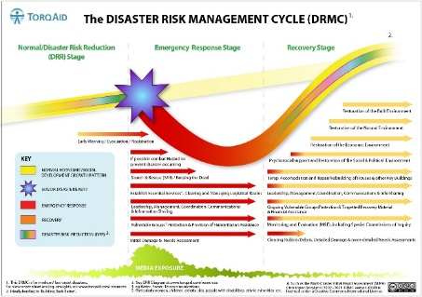

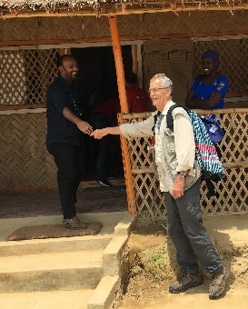
SC2a. Humanitarian Attitudes & Competencies.
- Five Key Attributes (5KAs) of the Humanitarian Practitioner
- The ELRHA Humanitarian Competency Framework
- Humanitarian stories from the field

SC2b. Humanitarian Standards and Codes of Conduct
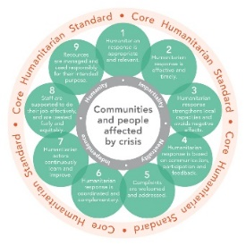
- Historical Background to Humanitarianism
- The Sphere Handbook
- The Core Humanitarian Standard (CHS) on Quality & Accountability

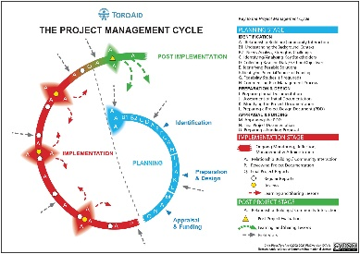
SC2c. Participatory Project Management (PPM). Teaching Principles & Tips
- The Project Management Cycle (PMC)
- The Project Design Document (PDD)
- Teaching Principles & Tips

SC3a. The DRR diagram and the Sendai Framework for Disaster Risk Reduction (SFDRR). The ISO 31000 Risk Management process
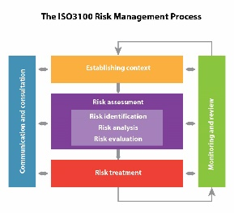
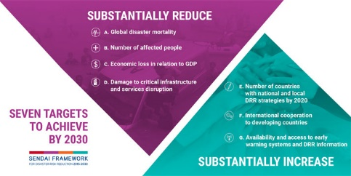
- The DRR diagram and the SFDRR
- The ISO 31000 Risk Management Process

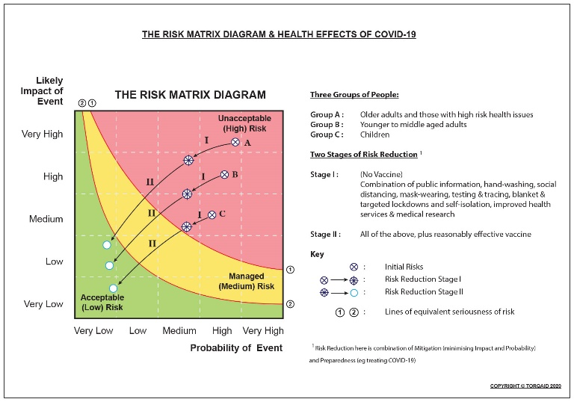
SC3b. Covid-19 Risk Management
- An overview of the global Covid-19 pandemic since early 2020
- Various risk management measures used to combat the occurrence and effects of Covid-19

SC3c. The Ten Seed Technique (TST) ranking tool . Community Based Disaster Risk Management (CBDRM) Initiatives in Vanuatu, Laos & Bangladesh (Rohingya)
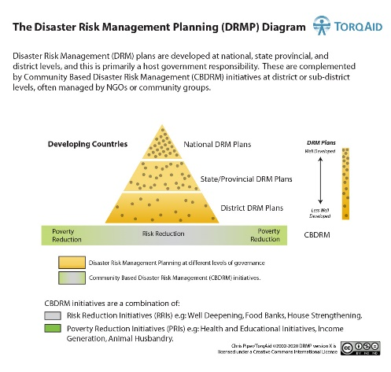
- The TST ranking tool
- CBDRM initiatives in Vanuatu, Laos
& Bangladesh (Rohingya)
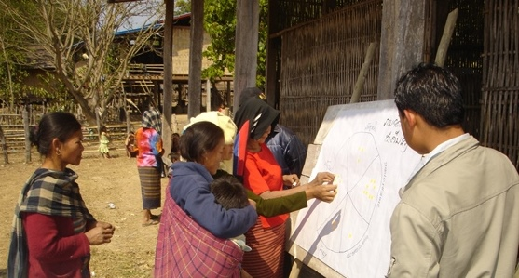

SC4a. Complex Emergencies/Crises, including Humanitarian Updates on Afghanistan
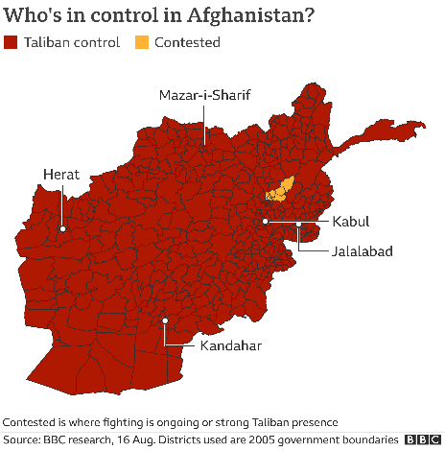
- UNOCHA & ACAPS Global
Overviews of countries in crisis
- An update on the current
humanitarian situation in Afghanistan

SC4b. The Rohingya refugees (forcibly Displaced Myanmar Nationals) Case Study
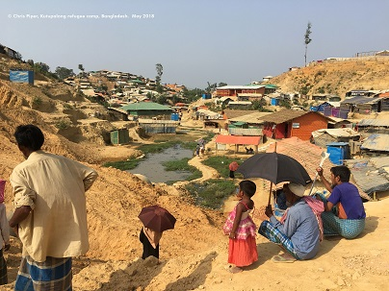
- Understanding the Background Context
- Overview of Humanitarian Operations in Cox’s Bazar since August 2017
- Future Options & Challenges

SC4c. Humanitarian Case Studies from the Yemen
& Tigray
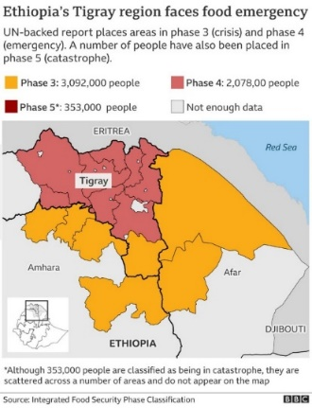
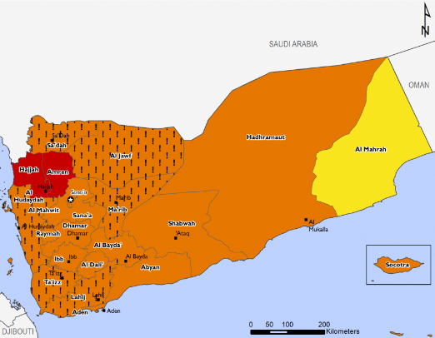
- Update on the Yemen humanitarian situation
- Update on the Tigray humanitarian situation

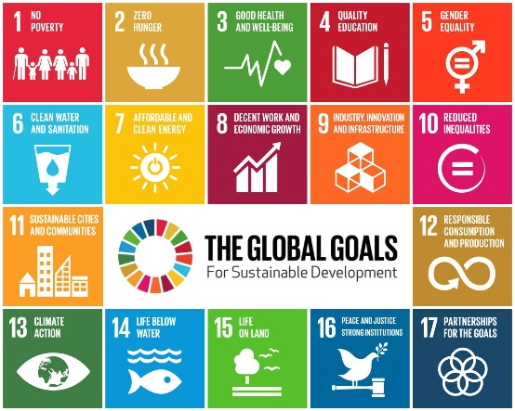
SC5a. THE DRR diagram and the Sustainable Development Goals (SDGs)
- Link between the DRR diagram and the SDGS
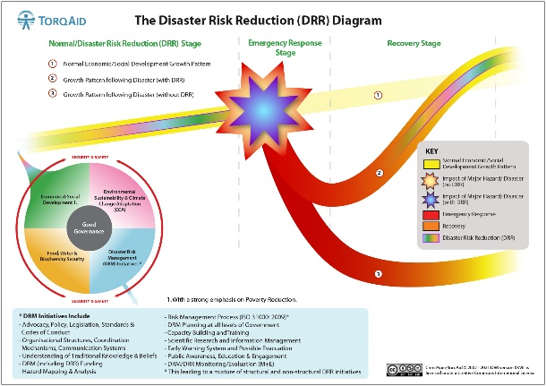
- Likely impact of Covid-19 on progress towards the SDGs

SC5b. Climate Change and the road to COP 26
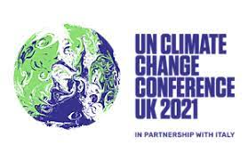
- Climate Change Explained (particularly IPCC’s latest AR6 Report)
- Causes of Greenhouse Gases (GHGs)
- Paris Climate Agreement & COP26
- Effects of Climate Change
- COP26 Challenges

Short Course Program August-October 2021
Note the Humanitarian Short Course (SC) program which coincides with the weekly taught sessions for the 2021 PDRM. These each last one hour on Wednesday teaching sessions at 8pm Melbourne time. The registration form can be found at the Annex to this document. This teaching session will be accompanied by topic notes beforehand, and a Zoom recording afterwards.

Humanitarian Short Course (SC) Topics | Date (all at 8pm Melbourne time)
SC1: Disaster Risk Management (DRM). Four key diagrams | Wed 11th August
SC2a. Humanitarian Practitioner Attitudes & Competencies | Wed 18th August
SC2b: Humanitarian Standards & Codes of Conduct | Wed 25th August
SC2c: Participatory Project Management (PPM). Teaching Principles & Tips | Wed 1st September
SC3a: The DRR diagram & SFDRR. The ISO 31000 risk management framework | Wed 8th September
SC3b: Covid-19 Risk Management | Wed 15th September
SC3c: The TST ranking tool. CBDRM initiatives in Vanuatu, Laos & Bangladesh (Rohingya) | Wed 22nd September
SC4a: Complex Emergencies/Crises, with an update on Afghanistan humanitarian situation | Wed 29th September
SC4b: The Rohingya refugees humanitarian case study | Wed 6th October
SC4c: Update on the Yemen & Tigray humanitarian situations | Wed 13th October
SC5a: The DRR diagram & the Sustainable Development Goals (SDGs) | Wed 20th October
SC5b: Climate Change & the road to COP 26 | Wed 27th October

The cost of each of these sessions is AUD 165, which includes the Australian 10% Goods & Services Tax (GST). Note that wef 12th October 2021, the final three topics (SC4a, SC5a, SC5b) will be discounted 50%.

Application forms for this Humanitarian SC program can be found in Annex A.

For further details of this Short Course (SC) program, please contact:
Chris Piper, TorqAid Director
TorqAid – www.torqaid.com
pipercm@iprimus.com.au
October 2021

ANNEX A: REGISTRATION FORM FOR TORQAID HUMANITARIAN SHORT COURSE (SC) PROGRAM,
OCTOBER 2021

Overview
The 2021 Humanitarian Short Course (SC) program runs from the 11th August through to the 27th October 2021.

Registration & Payment Details
Interested participants should register on this form. A tax invoice will then be sent out, and payment then made. Payment can be made in two ways (please indicate your preference):
o PayPal

o Electronic Funds Transfer (EFT).

Registration Details
Name

Organisation

Address/Country

Phone Number

Email

SC Topic details (tick individual topics)
□ SC5a: Climate Change & the road
to COP 26 (20th Oct)

□ SC5b: The DRR diagram & the
SDGs (27th Oct)

Discounts
Note that wef 12th October, these final three topics have been discounted 50%.

SC Topic Costs
The cost of each SC topics is Australian Dollars (AUD) 165 each (this includes GST). With a 50% discount, this now equates to AUD 82.50 each.

Total cost (include discounted amount where relevant): AUD

Payment Details
TorqAid will the issue a tax invoice on your instructions. As already mentioned, this can be paid either by EFT or PayPal.

Completed Registration Form
Please email completed the Registration Form to:
Mr Chris Piper, Director, TorqAid
pipercm@iprimus.com.au
www.torqaid.com

See this paper at www.torqaid.com/short-courses
See www.torqaid.com/online-pdrm-program
Namely the Disaster Risk Management Cycle (DRMC), Disaster Risk Reduction (DRR) diagram, Disaster Risk Management (DRM) Planning diagram, and the Project Management Cycle (PMC)
The United Nation’s Climate Change Conference, being held in Glasgow, November 2021
The current one runs from the 26th July through to the 5th November 2021
All of these can be found in the article www.torqaid.com/drm-framework
See www.torqaid.com/online-pdrm-program
Or alternatively at www.torqaid.com/short-courses
Australian Dollars

